Train acc：

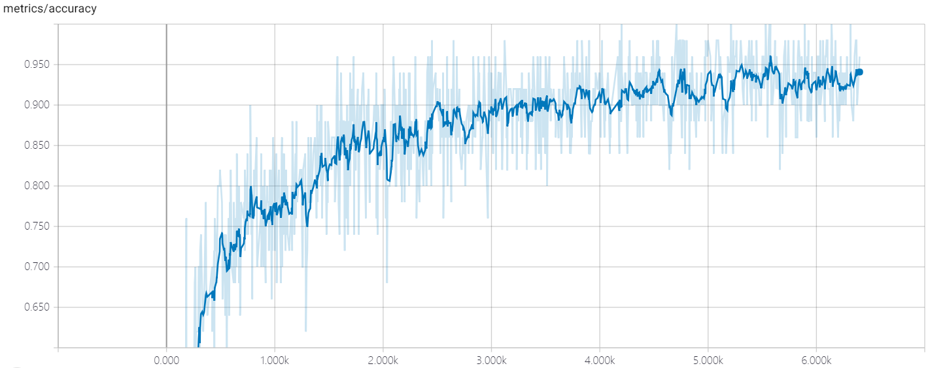

Train loss:

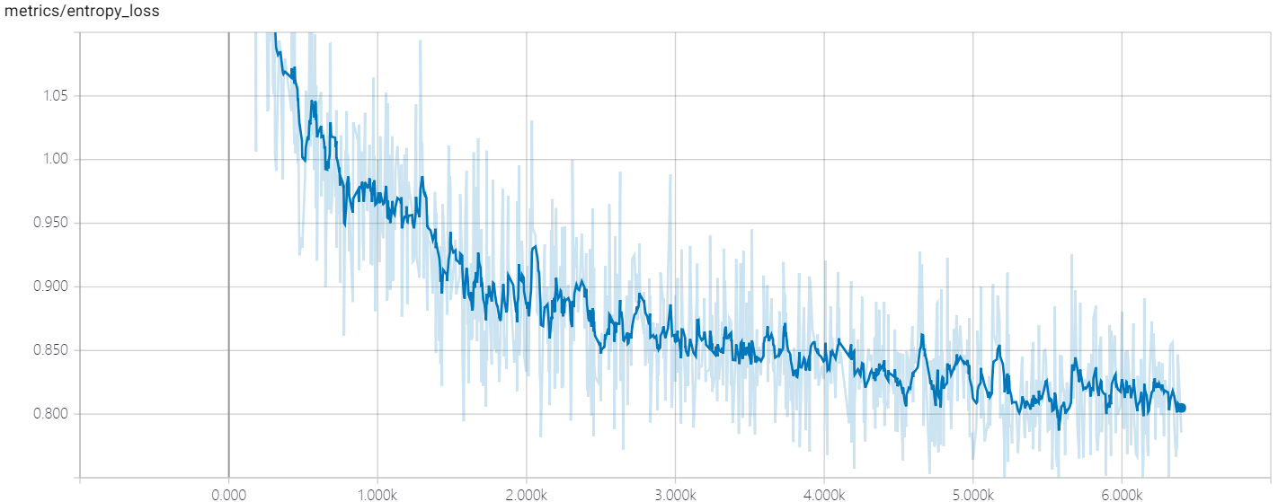

Test acc:

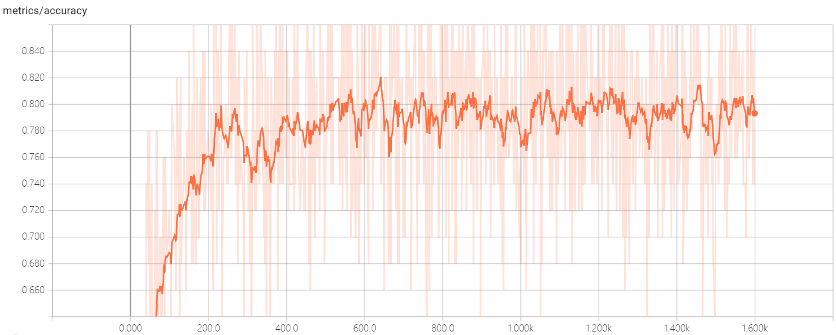

Test loss:

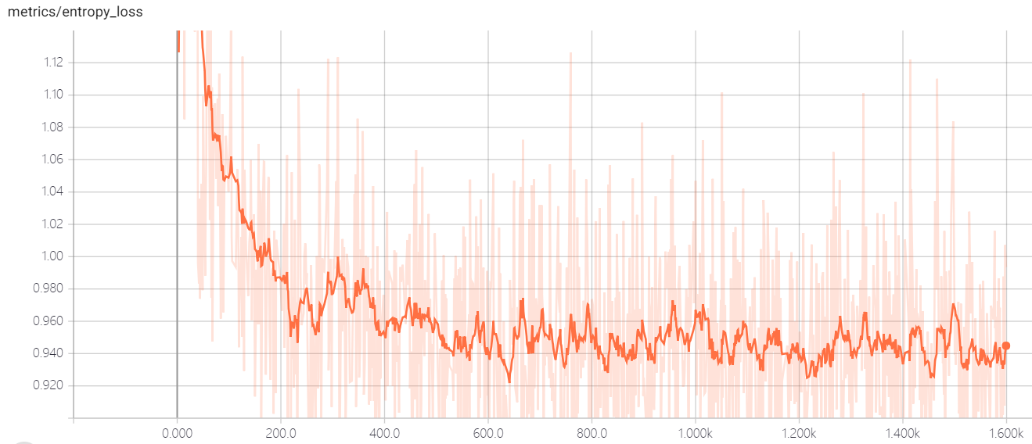

Train vs test: acc:

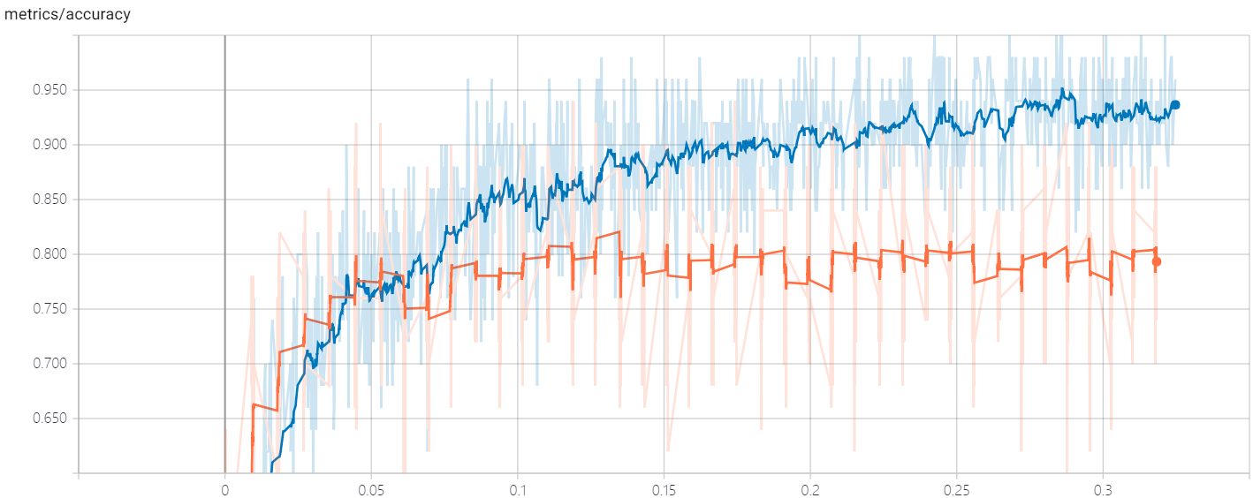

Train vs test: loss:

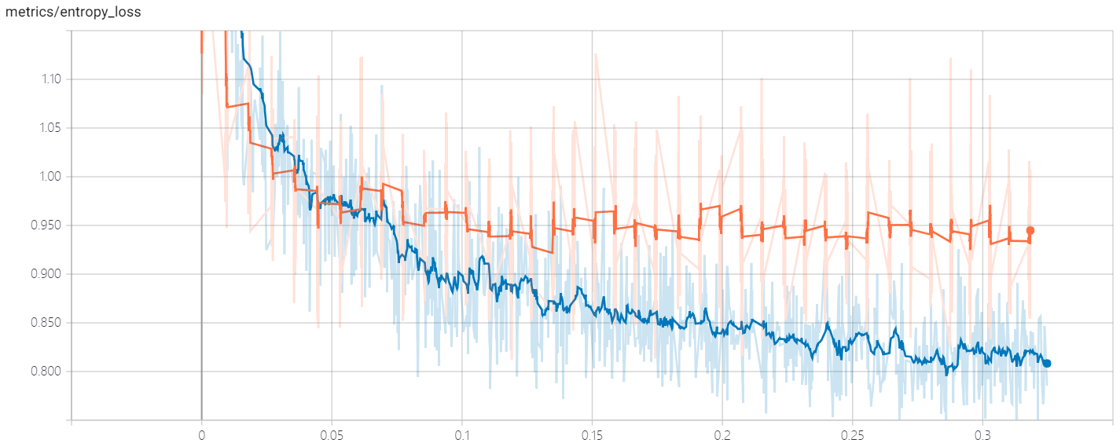

Test Rnn output histogram:

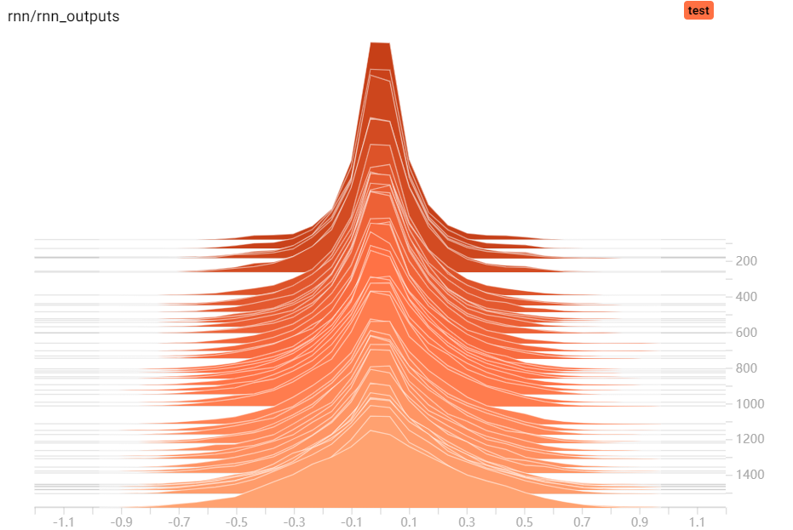

Train Rnn output histogram:

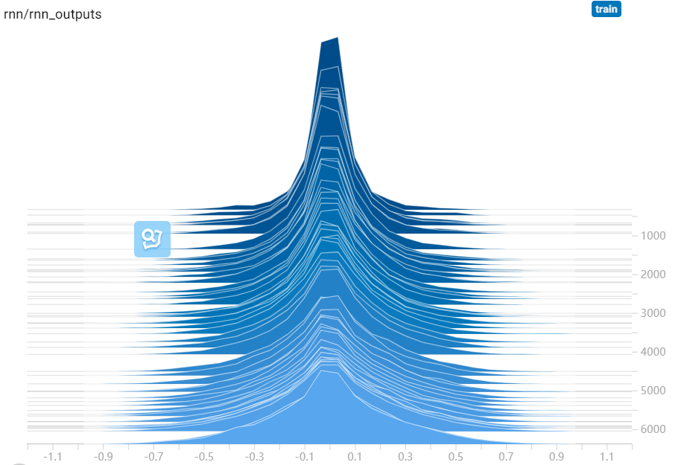

Model graph:

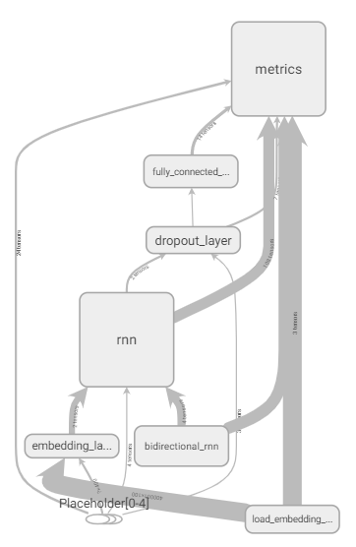

Final result:

**loss: 0.818, val_loss: 0.941, acc: 0.923, val_acc: 0.800**

training begins...

epoch: 0

100%|██████████| 160/160 [00:27<00:00, 6.07it/s]

100%|██████████| 40/40 [00:03<00:00, 12.23it/s]

loss: 1.250, val_loss: 1.267, acc: 0.449, val_acc: 0.464

save model to./labeled_model/model.ckpt

epoch: 1

100%|██████████| 160/160 [00:27<00:00, 6.05it/s]

100%|██████████| 40/40 [00:03<00:00, 13.25it/s]

loss: 1.071, val_loss: 1.047, acc: 0.599, val_acc: 0.685

save model to./labeled_model/model.ckpt

epoch: 2

100%|██████████| 160/160 [00:26<00:00, 6.12it/s]

100%|██████████| 40/40 [00:03<00:00, 13.15it/s]

loss: 1.070, val_loss: 1.024, acc: 0.683, val_acc: 0.718

save model to./labeled_model/model.ckpt

epoch: 3

100%|██████████| 160/160 [00:26<00:00, 6.33it/s]

100%|██████████| 40/40 [00:03<00:00, 13.26it/s]

loss: 1.017, val_loss: 1.001, acc: 0.717, val_acc: 0.744

save model to./labeled_model/model.ckpt

epoch: 4

100%|██████████| 160/160 [00:26<00:00, 6.17it/s]

100%|██████████| 40/40 [00:03<00:00, 13.40it/s]

loss: 1.046, val_loss: 0.991, acc: 0.744, val_acc: 0.754

save model to./labeled_model/model.ckpt

epoch: 5

100%|██████████| 160/160 [00:26<00:00, 6.13it/s]

100%|██████████| 40/40 [00:02<00:00, 13.44it/s]

loss: 0.991, val_loss: 0.970, acc: 0.764, val_acc: 0.776

save model to./labeled_model/model.ckpt

epoch: 6

100%|██████████| 160/160 [00:25<00:00, 6.21it/s]

100%|██████████| 40/40 [00:03<00:00, 13.04it/s]

loss: 0.993, val_loss: 0.978, acc: 0.779, val_acc: 0.767

model is not improved in current epoch!

epoch: 7

100%|██████████| 160/160 [00:25<00:00, 6.29it/s]

100%|██████████| 40/40 [00:03<00:00, 13.36it/s]

loss: 0.989, val_loss: 0.982, acc: 0.794, val_acc: 0.757

model is not improved in current epoch!

epoch: 8

100%|██████████| 160/160 [00:25<00:00, 6.22it/s]

100%|██████████| 40/40 [00:03<00:00, 13.41it/s]

loss: 1.002, val_loss: 0.974, acc: 0.804, val_acc: 0.767

model is not improved in current epoch!

model is not improved in the last 3 epoch, reduced learning rate!

epoch: 9

100%|██████████| 160/160 [00:25<00:00, 6.12it/s]

100%|██████████| 40/40 [00:02<00:00, 13.74it/s]

loss: 0.883, val_loss: 0.954, acc: 0.834, val_acc: 0.788

save model to./labeled_model/model.ckpt

epoch: 10

100%|██████████| 160/160 [00:25<00:00, 6.31it/s]

100%|██████████| 40/40 [00:02<00:00, 13.36it/s]

loss: 0.880, val_loss: 0.952, acc: 0.842, val_acc: 0.788

model is not improved in current epoch!

epoch: 11

100%|██████████| 160/160 [00:26<00:00, 5.70it/s]

100%|██████████| 40/40 [00:03<00:00, 13.34it/s]

loss: 0.867, val_loss: 0.954, acc: 0.847, val_acc: 0.788

model is not improved in current epoch!

epoch: 12

100%|██████████| 160/160 [00:25<00:00, 6.13it/s]

100%|██████████| 40/40 [00:02<00:00, 13.54it/s]

loss: 0.874, val_loss: 0.951, acc: 0.851, val_acc: 0.790

save model to./labeled_model/model.ckpt

epoch: 13

100%|██████████| 160/160 [00:25<00:00, 6.44it/s]

100%|██████████| 40/40 [00:02<00:00, 13.46it/s]

loss: 0.900, val_loss: 0.951, acc: 0.859, val_acc: 0.791

save model to./labeled_model/model.ckpt

epoch: 14

100%|██████████| 160/160 [00:25<00:00, 6.33it/s]

100%|██████████| 40/40 [00:02<00:00, 13.62it/s]

loss: 0.863, val_loss: 0.949, acc: 0.864, val_acc: 0.791

model is not improved in current epoch!

epoch: 15

100%|██████████| 160/160 [00:25<00:00, 6.52it/s]

100%|██████████| 40/40 [00:02<00:00, 13.87it/s]

loss: 0.876, val_loss: 0.949, acc: 0.872, val_acc: 0.793

save model to./labeled_model/model.ckpt

epoch: 16

100%|██████████| 160/160 [00:25<00:00, 6.23it/s]

100%|██████████| 40/40 [00:02<00:00, 13.35it/s]

loss: 0.887, val_loss: 0.951, acc: 0.876, val_acc: 0.789

model is not improved in current epoch!

epoch: 17

100%|██████████| 160/160 [00:25<00:00, 6.28it/s]

100%|██████████| 40/40 [00:02<00:00, 13.65it/s]

loss: 0.881, val_loss: 0.948, acc: 0.882, val_acc: 0.792

model is not improved in current epoch!

epoch: 18

100%|██████████| 160/160 [00:25<00:00, 5.70it/s]

100%|██████████| 40/40 [00:02<00:00, 13.88it/s]

loss: 0.829, val_loss: 0.950, acc: 0.887, val_acc: 0.792

model is not improved in current epoch!

model is not improved in the last 3 epoch, reduced learning rate!

epoch: 19

100%|██████████| 160/160 [00:25<00:00, 6.43it/s]

100%|██████████| 40/40 [00:02<00:00, 13.40it/s]

loss: 0.872, val_loss: 0.949, acc: 0.891, val_acc: 0.788

model is not improved in current epoch!

model is not improved in the last 4 epoch, reduced learning rate!

epoch: 20

100%|██████████| 160/160 [00:24<00:00, 6.40it/s]

100%|██████████| 40/40 [00:02<00:00, 13.90it/s]

loss: 0.854, val_loss: 0.948, acc: 0.893, val_acc: 0.792

model is not improved in current epoch!

model is not improved in the last 5 epoch, reduced learning rate!

epoch: 21

100%|██████████| 160/160 [00:25<00:00, 5.92it/s]

100%|██████████| 40/40 [00:03<00:00, 12.89it/s]

loss: 0.867, val_loss: 0.947, acc: 0.897, val_acc: 0.795

save model to./labeled_model/model.ckpt

epoch: 22

100%|██████████| 160/160 [00:26<00:00, 6.27it/s]

100%|██████████| 40/40 [00:03<00:00, 13.01it/s]

loss: 0.852, val_loss: 0.947, acc: 0.901, val_acc: 0.790

model is not improved in current epoch!

epoch: 23

100%|██████████| 160/160 [00:25<00:00, 6.08it/s]

100%|██████████| 40/40 [00:03<00:00, 13.05it/s]

loss: 0.842, val_loss: 0.946, acc: 0.903, val_acc: 0.793

model is not improved in current epoch!

epoch: 24

100%|██████████| 160/160 [00:25<00:00, 6.39it/s]

100%|██████████| 40/40 [00:02<00:00, 13.84it/s]

loss: 0.852, val_loss: 0.948, acc: 0.907, val_acc: 0.790

model is not improved in current epoch!

model is not improved in the last 3 epoch, reduced learning rate!

epoch: 25

100%|██████████| 160/160 [00:25<00:00, 6.33it/s]

100%|██████████| 40/40 [00:02<00:00, 13.65it/s]

loss: 0.811, val_loss: 0.947, acc: 0.909, val_acc: 0.794

model is not improved in current epoch!

model is not improved in the last 4 epoch, reduced learning rate!

epoch: 26

100%|██████████| 160/160 [00:25<00:00, 6.22it/s]

100%|██████████| 40/40 [00:02<00:00, 13.25it/s]

loss: 0.834, val_loss: 0.946, acc: 0.913, val_acc: 0.795

save model to./labeled_model/model.ckpt

epoch: 27

100%|██████████| 160/160 [00:25<00:00, 6.38it/s]

100%|██████████| 40/40 [00:02<00:00, 13.71it/s]

loss: 0.824, val_loss: 0.945, acc: 0.914, val_acc: 0.793

model is not improved in current epoch!

epoch: 28

100%|██████████| 160/160 [00:25<00:00, 6.14it/s]

100%|██████████| 40/40 [00:02<00:00, 13.58it/s]

loss: 0.852, val_loss: 0.945, acc: 0.917, val_acc: 0.795

model is not improved in current epoch!

epoch: 29

100%|██████████| 160/160 [00:25<00:00, 6.38it/s]

100%|██████████| 40/40 [00:02<00:00, 13.62it/s]

loss: 0.874, val_loss: 0.946, acc: 0.920, val_acc: 0.793

model is not improved in current epoch!

model is not improved in the last 3 epoch, reduced learning rate!

epoch: 30

100%|██████████| 160/160 [00:25<00:00, 6.10it/s]

100%|██████████| 40/40 [00:03<00:00, 13.44it/s]

loss: 0.805, val_loss: 0.945, acc: 0.922, val_acc: 0.791

model is not improved in current epoch!

model is not improved in the last 4 epoch, reduced learning

rate!

epoch: 31

100%|██████████| 160/160 [00:25<00:00, 6.32it/s]

100%|██████████| 40/40 [00:02<00:00, 13.87it/s]

**loss: 0.818, val_loss: 0.941, acc: 0.923, val_acc: 0.800**

save model to./labeled_model/model.ckpt

epoch: 32

100%|██████████| 160/160 [00:25<00:00, 5.93it/s]

100%|██████████| 40/40 [00:03<00:00, 12.32it/s]

loss: 0.862, val_loss: 0.942, acc: 0.924, val_acc: 0.796

model is not improved in current epoch!

epoch: 33

100%|██████████| 160/160 [00:26<00:00, 6.32it/s]

100%|██████████| 40/40 [00:02<00:00, 13.48it/s]

loss: 0.805, val_loss: 0.943, acc: 0.925, val_acc: 0.795

model is not improved in current epoch!

epoch: 34

100%|██████████| 160/160 [00:25<00:00, 6.10it/s]

100%|██████████| 40/40 [00:02<00:00, 13.87it/s]

loss: 0.837, val_loss: 0.941, acc: 0.927, val_acc: 0.796

model is not improved in current epoch!

model is not improved in the last 3 epoch, reduced learning rate!

epoch: 35

100%|██████████| 160/160 [00:24<00:00, 6.59it/s]

100%|██████████| 40/40 [00:02<00:00, 13.94it/s]

loss: 0.819, val_loss: 0.941, acc: 0.928, val_acc: 0.794

model is not improved in current epoch!

model is not improved in the last 4 epoch, reduced learning rate!

epoch: 36

100%|██████████| 160/160 [00:24<00:00, 6.63it/s]

100%|██████████| 40/40 [00:02<00:00, 14.40it/s]

loss: 0.814, val_loss: 0.941, acc: 0.929, val_acc: 0.796

model is not improved in current epoch!

model is not improved in the last 5 epoch, reduced learning rate!

epoch: 37

100%|██████████| 160/160 [00:24<00:00, 6.69it/s]

100%|██████████| 40/40 [00:02<00:00, 14.35it/s]

loss: 0.872, val_loss: 0.943, acc: 0.930, val_acc: 0.794

model is not improved in current epoch!

model is not improved in the last 6 epoch, reduced learning rate!

epoch: 38

100%|██████████| 160/160 [00:24<00:00, 6.58it/s]

100%|██████████| 40/40 [00:02<00:00, 13.98it/s]

loss: 0.794, val_loss: 0.943, acc: 0.931, val_acc: 0.792

model is not improved in current epoch!

model is not improved in the last 7 epoch, reduced learning rate!

epoch: 39

100%|██████████| 160/160 [00:24<00:00, 6.67it/s]

100%|██████████| 40/40 [00:02<00:00, 13.41it/s]

loss: 0.813, val_loss: 0.942, acc: 0.932, val_acc: 0.795

model is not improved in current epoch!

model is not improved in the last 8 epoch, early stopped!

training ends...